### HUMBER COLLEGE

Group Assignment

### COURSE: BIA 5000

### TEAM: < 2 >

### SUBMITTED BY:

### 

| Last Name | First Name | Student Number |
| --- | --- | --- |
| Mathew | Alan | N01604305 |
| Chatterjee | Ayantika | N01605074 |
| Dutta | Bishwajit | N01604226 |
| Ganesan | Swathimathi | N01601838 |
| Kamboj | Taranjeet | N01588653 |
| Saluja | Tashmeet Kaur | N01604831 |
| Sekhri | Vanshaj | N01616496 |

## 

## SUBMITTED TO: Prof. Yulia Kosarenko

**About the companyIntroduction** - GrabANut is a manufacturing unit operating since 2004 in Greater Vancouver. The company supplies various types of nuts to different retailers including local stores.

Company Name - **GrabANut**

Company size - Small to medium-sized Enterprise (SME)

Location - Richmond

**Key Products:**

* Pistachios: Shelled, de-shelled; available in multiple flavors
* Cashews: Premium cashews, plain or seasoned
* Almonds - High-quality almonds, roasted, salted, and chocolate-coated almonds.

**Market Focus:**

* Retail market including supermarkets, convenience stores, and online platforms
* Customized packaging for corporate gifts and special occasions

**Key Challenges:**

* The decline in Sales of a specific product due to various factors over some time.
* Seasonal challenges in nut production and availability.

# Step 1

For each question, explain:

* What type of analytics will you use to answer the question?
* How will answering this question help to solve the business problem?
* What data will be required to answer this question?
* Is a prediction required to answer the question? What would be the response variable?
* What decisions could be made using these insights?

**Descriptive and diagnostic analytical questions:**

1. What are the annual sales of all the categories of pistachios over the last 3 years?
   1. With the use of Descriptive Analysis.
   2. To know the data insights of previous sales reports.
   3. Annual sales report of previous 3 years
   4. No prediction is required.
2. What categories of pistachios(shelled/unshelled) do well in the market in terms of sales?
   1. With the use of Descriptive Analysis.
   2. We will boost the sales of the product which is not performing well.
   3. Real-time product performance data
   4. No prediction is required
3. When was the drop in sales observed?
   1. With the use of Descriptive analysis.
   2. It’ll help us to create a strategy to increase the demand for shelled pistachios.
   3. Monthly sales report
   4. No prediction is required
4. Are there any specific retailers where there has been a drastic drop in shelled pistachio sales?
   1. With the use of Predictive analysis.
   2. We’ll focus on implementing better strategies to enhance the dropped sales from that particular customer segment.
   3. Order summary of each retailer.
   4. No prediction is required.
5. How did previous marketing and promotional efforts affect the sales of shelled pistachios?
6. With the use of Predictive analysis.
7. We’ll focus on previous marketing data, so we can get insights and enhance our new marketing strategies.
8. Purchase history and behavior. (Customer Engagement data)
9. No prediction is required.

# Step 2

**Predictive and prescriptive analytical questions:**

**Criteria for each question**

* What type of analytics will you use to answer the question?
* How will answering this question help to solve the business problem?
* What data will be required to answer this question?
* Is a prediction required to answer the question? What would be the response variable?

1. What is the expected sales trend for shelled pistachios in the upcoming quarter, considering the historical decline in sales of shelled pistachios?
   1. With the use of Predictive Analysis.
   2. We’ll mitigate the factors responsible for the decline in sales of shelled pistachios.
   3. Previous quarterly sales records and market research data.
   4. Yes, the prediction is required. Expected sales will be the response variable.
2. How might the decline in shelled pistachio sales affect our overall revenue for the next fiscal year?
3. With the use of Predictive Analysis.
4. We’ll mitigate the factors responsible for the decline in sales of shelled pistachios to avoid a reduction in revenue.
5. Revenue Breakdown: Data categorizing revenue streams from shelled pistachio sales.
6. Prediction is required. Expected revenue for next year as the response variable.
7. What is the expected sales trend for shelled pistachios in the upcoming quarter, considering the historical decline in sales of shelled pistachios?
   1. With the use of Prescriptive Analysis.
   2. By predicting the sales trend for shelled pistachios in the upcoming quarter, businesses can make informed decisions regarding production, inventory, marketing, and sales strategies.
   3. Marketing and Promotion Data: Data on past marketing campaigns and promotions, as these may impact sales.
   4. Yes, the response variable would be the expected sales volume or revenue for shelled pistachios in the upcoming quarter.
8. How will marketing schemes affect the sales of pistachios in the future?
9. With the use of Prescriptive Analysis.
10. Answering this question can provide valuable insights into the effectiveness of marketing schemes and their impact on pistachio sales.
11. Purchase history and behavior. (Customer Engagement data)
12. Yes, the response variable would be the expected increase in sales or the overall impact on sales due to the implementation of specific marketing schemes.

# Step 3

**Entities Description:**

**1. Product:** This entity is used to represent the various nut products produced and sold by GrabANut. Each product is assigned a Product_ID, Product_Name, Price.  
  
**Attributes:**

**Product_ID:** Primary key for the Product entity; consists of the unique number provided to each product.

**Price:** The amount at which the product is sold.

**Product_Name:** This specifies the name of each product the company is selling.

**2. Inventory:** The Inventory entity monitors the amount of each product in stock. It is linked to the Product entity via a Foreign Key (Product_ID) that links each item in stock to a particular product. This entity facilitates the management of inventory levels and turnover rates of different products.

**Attributes:**

**Stock_Quantity:** The amount of inventory available for products.

**Inventory_ID:** Primary key and it is the unique ID allotted to every inventory

**Product_ID:** Foreign key consists of the unique number provided to each product.

**Units_Sold:** No. of products sold.

**3. Retailer:** The Retailer entity is the entity that purchases nut products from GrabAnut. It contains attributes such as a Retailer_ID, Retailer_Name, Location. The Retailer entity is related to the Product entity in a many-to-many relationship, as retailers can purchase multiple products and products can be marketed by multiple retailers.

**Location:** The geographical details of the retailer.

**Retailer_ID:** Primary key, consists of the unique number provided to each retailer.  
  
**Retailer_Name:** Name of the retailer.

**4. Order:** This item represents customer orders. It contains attributes like Order_ID (primary key), Order_Date, and Retailer_ID (foreign key). Orders are tied to specific products and retailers.

**Attributes:**

**Order_ID:** Primary key for the Order entity; consists of the unique number assigned to every order.

**Order Date:** Includes the date the order was placed.

**Retailer_ID:** Foreign key, the unique number provided to each retailer.

**5. Order_Details:** This entity stores information related to order details. It contains attributes like Order_Detail_ID(Primary Key), Order_ID(foreign key), Product_ID(foreign key) and Total_Price. This entity combines sales data with products and promotions.

**Attributes:  
  
Order_Detail_ID:** Primary key for the Order_Details entity; consists of the unique ID allotted to every order detail.

**Total_Price:** The final summation of the whole order.

**Order_ID:** Foreign consists of the unique number assigned to every order.

**Product_ID:** Foreign consists of the unique number assigned to every order.

**6. Promotion:** The promotion entity stores information about different campaigns. It contains Promotion_ID (primary key), Product_ID (foreign key), Promotion_Date, and Promotion_Type. This item links offers to specific products.

**Attributes:**

**Promotion_ID:** Primary key for the Promotion entity; consists of the unique ID allotted to every promotion strategy.

**Promotion_Type:** The medium of communication used for the promotion of a product.

**Product_ID:** Foreign key consists of the unique number provided to each product.

**Promotion_Date:** Launch date of a product promotion.

**7. Delivery:** This entity manages order delivery information. It contains attributes such as Delivery_ID, Delivery_Date, Tracking_No, Retailer_ID (foreign key) and Order_No (foreign key). This entity links shipments to orders, retailers, and products.

**Attributes:**

**Delivery_ID:** Primary key for the Delivery entity; consists of the unique number allotted to each delivery that takes place.

**Delivery_Date:** The date when the delivery was initiated.

**Order_ID:** Foreign consists of the unique number assigned to every order.

**Tracking_No:** The ID allocated to a delivery that is used to track.

**Retailer_id:** Foreign key, the unique number provided to each retailer.

**Step 4**

**ERD Diagram:**

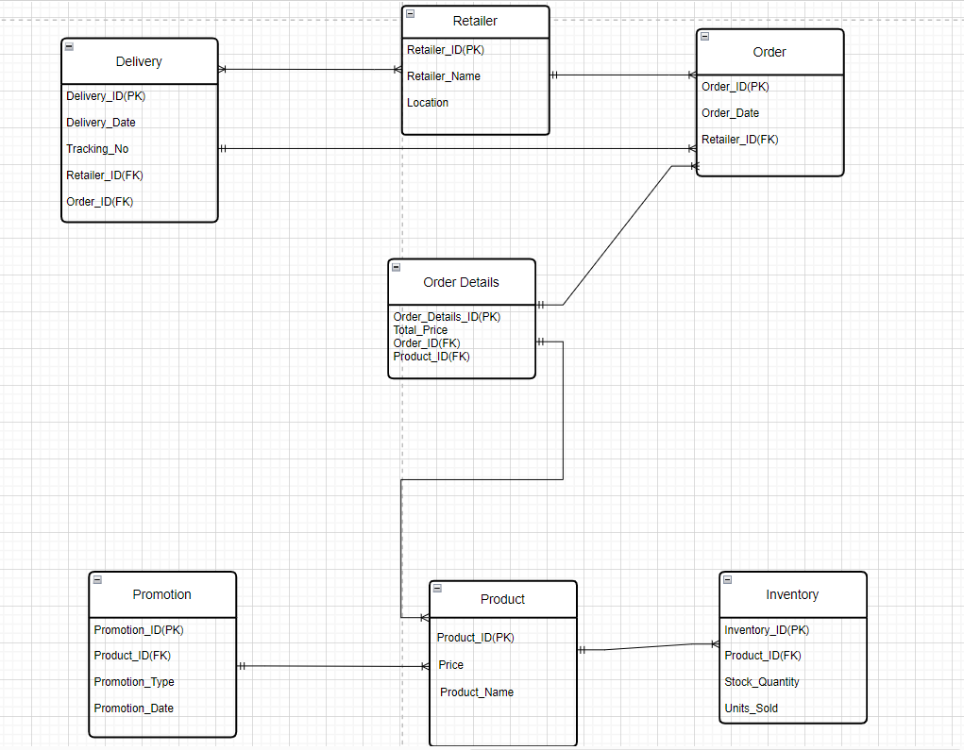

**Step 5**

**System of Records:**

**Customer Management System:**

**Main Users**: Customer support teams, sales departments, marketing teams, and management.

**Usage**: This system is used to manage customer relationships, track customer interactions, and gather data for marketing and sales efforts. Our main customers are retailers and wholesalers

**Main Sources of Data**: Customer input, Sales interactions, and Marketing data

**Sales Management System:**

**Main Users**: Sales representatives, Sales managers, and executives.

**Usage**: The sales department primarily uses the Customer Management System to access customer information, such as contact details, purchase history, and preferences. They use this data to engage with customers, close deals, and increase sales.

**Main Sources of Data**: Customer Management System, Sales activities, Marketing data

**Inventory Management System:**

**Main Users:** Inventory managers, procurement teams, and sometimes retail staff.

**Usage:** The Inventory Management System is used to track and manage the availability of products in stock. Inventory managers use it to monitor stock levels, place orders with suppliers, and optimize inventory to prevent overstocking or stockouts.

**Main Sources of Data**: Purchase orders, Sales orders, Stock counts, Supplier information

**Order Management System:**

**Main Users**: Order fulfillment teams, customer service, and warehouse staff.

**Usage:** The Order Management System is used to process and fulfill customer orders efficiently. It helps track order status, inventory availability, and shipping details. It ensures orders are processed accurately and delivered on time.

**Main Sources of Data**: Customer orders, Inventory data, Shipping, and logistics data

**Step 6**

**Context Diagram:**

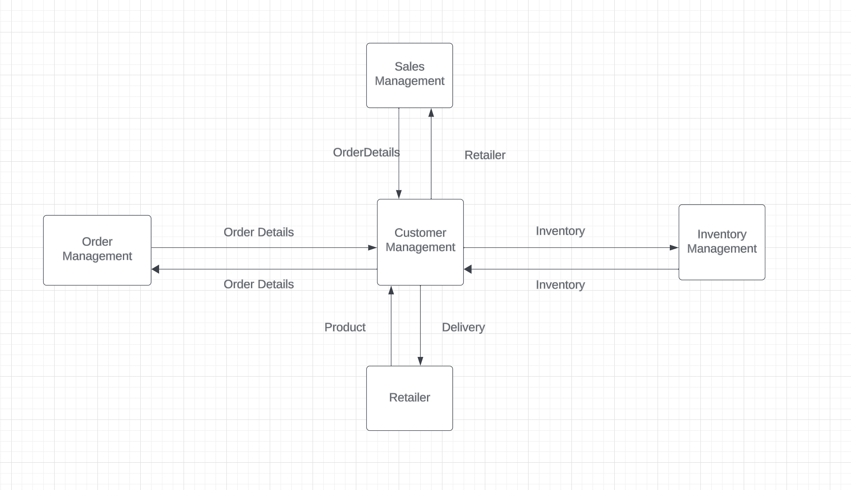

Looking at the diagram, it can be concluded that all the units depend on Customer Management. To gain any information, the units need to go through Customer Management. To understand it better, let’s dive deep into the diagram.1

**Scenario 1: Sales Management - Customer Management**

If a retailer needs to know about the purchase he made with the firm, he needs to provide the order details, the entity Retailer has the unique attribute Retailer_id that helps to retrieve the information from the Order Details entity.

**Scenario 2: Retailer - Customer Management**

If a retailer needs to know about the delivery details for a purchase he made with the firm, he needs to provide the product details, the entity Product has the unique attribute Product_id that helps to retrieve the information from the Delivery entity.

**Scenario 3&4: Order Management - Customer Management & Inventory Management - Customer Management**

To manage the orders received by the firm, it is necessary to know the unique attributes of that order. For the same, the information exchanged here is that of the Order Details entity.

Similarly, to manage the stock of the products, it is crucial to know about the details of the inventory, which is where the Inventory entity comes into the case.

**Step 7**

**Data Preparation and Data Wrangling Activities**

**1). Data Cleansing - Validity Check**

**Before:-**

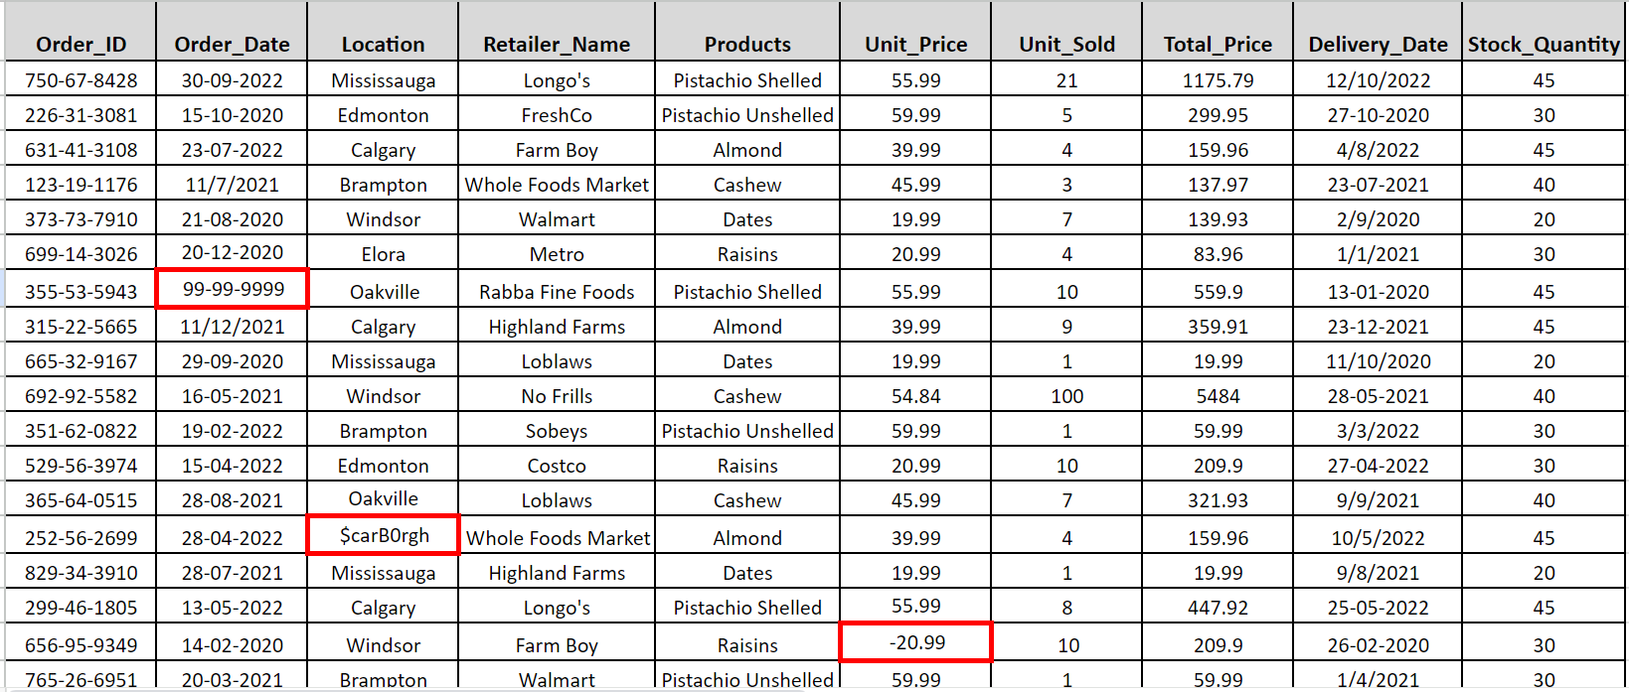

**After:-**

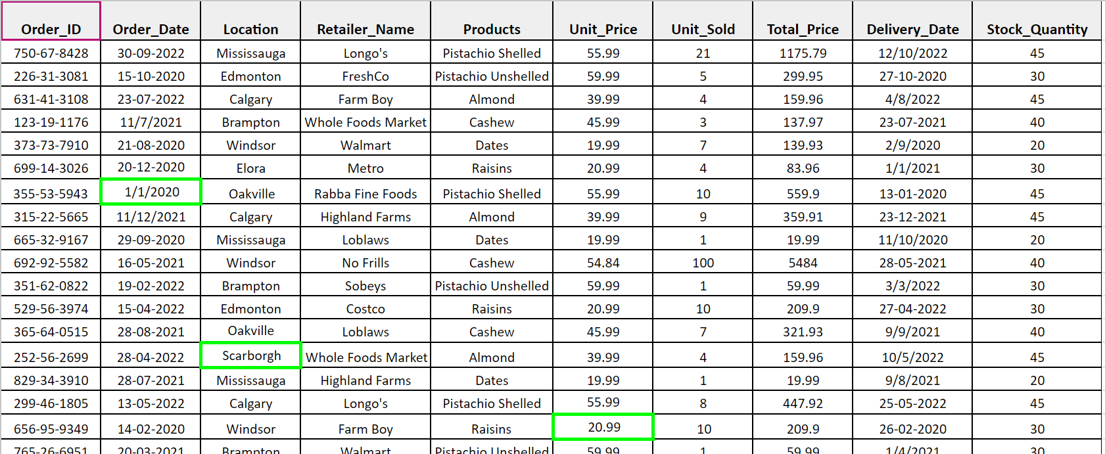

* **What is the goal of each activity?**

The goal of the activity is to check whether the data is out of range, invalid, or if it has any syntax error, irrelevancy, etc.

# What data will it impact? Use specific data entities as examples.

Order Entity will be impacted by an invalid date format specified under the Order date attribute.

Product Entity will be impacted by invalid unit Price as the price cannot be negative.

Retailer Entity will be impacted by incorrect data type under attribute location.

# Which system(s) will the data be coming from?

Retailer data will be coming from the retailer system.

Order and Product related data will be generated in the order management system of record.

# What issues do you anticipate and will address with these activities?

The data may not align with predefined constraints. We must ensure that data adheres to business rules and domain constraints by using data validation checks to maintain data consistency.

**2). Missing value**

**Before:-**

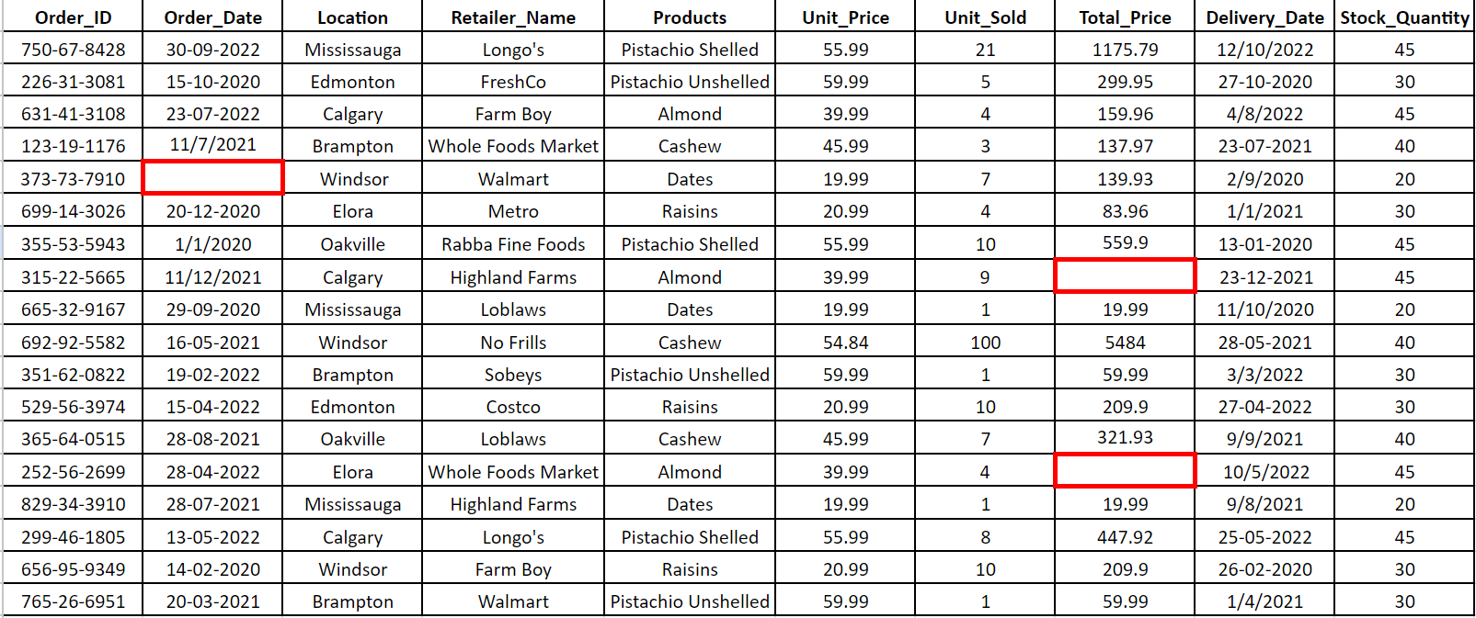

**After:-**

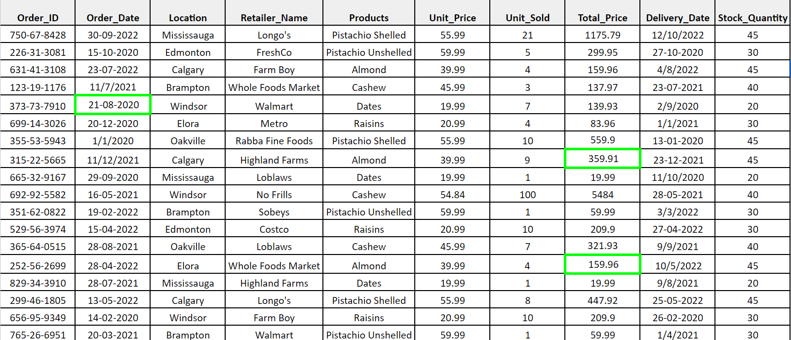

* **What is the goal of each activity?**

The purpose of this activity is to impute, discard, or flag the missing values depending on how the data is impacting our analysis.

# What data will it impact? Use specific data entities as examples.

Order_Date will impact Order Entity.

The total price will impact the Order_Detail entity.

# Which system(s) will the data be coming from?

Order_Date is coming from the order Management system of records.

# What issues do you anticipate and will address with these activities

Missing order dates will create difficulty in the order tracking. The missing Total price will disrupt the operations, as more time and effort will be spent on looking for the missing value. We are trying to impute the missing values of the total price by calculating the values through units sold and unit price. To figure out the order date, we know the delivery date, and using historical data we are calculating how long an order usually takes to get delivered and then imputing the value for the order date.

# 

# 3. Duplicate Data Values

**Before -**

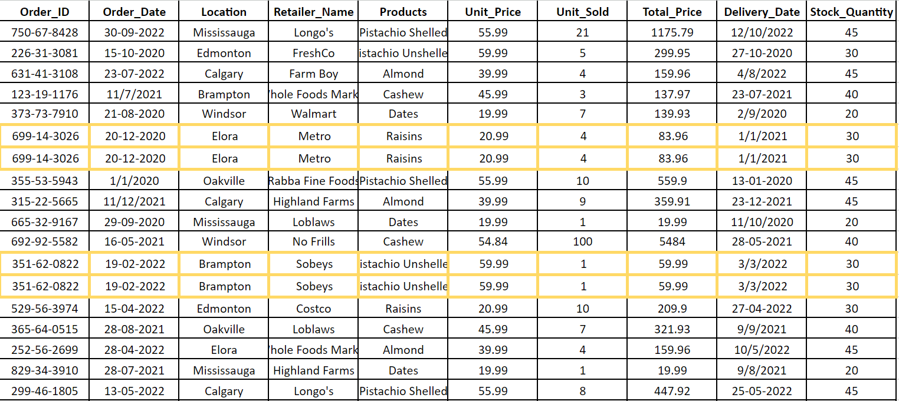

**After -**

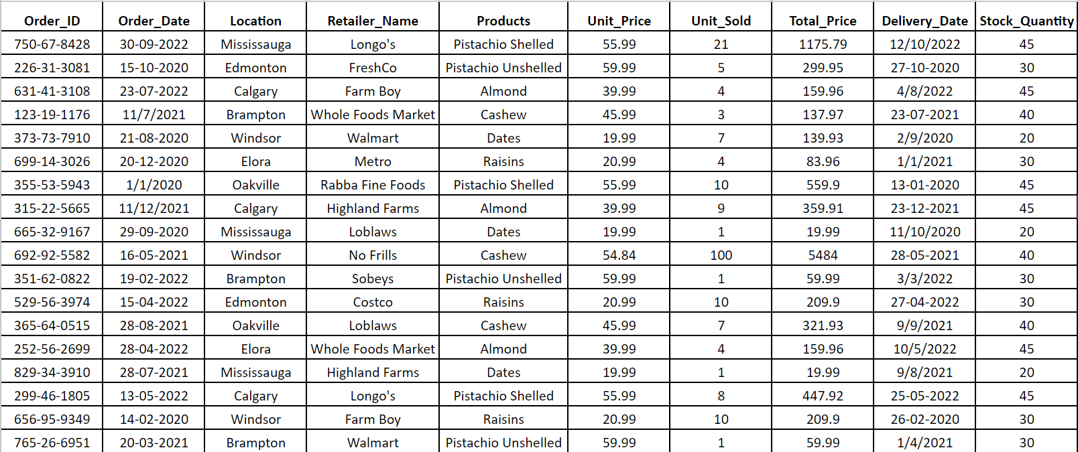

* **What is the goal of each activity?**

Dealing with duplicate data in a table is an important data-cleaning task to ensure data integrity and data accuracy. We can handle duplicates by removing, flagging, or aggregating the data.

# What data will it impact? Use specific data entities as examples.

Every entity will be impacted as all the attributes for each entity are repeated

# Which system(s) will the data be coming from?

The data is coming from Customer management systems.

# What issues do you anticipate and will address with these activities?

The duplicates represent redundant data and we want to keep only one copy by removing the duplicate rows. This is done to keep the data clean and prevent distortions in analysis; duplicate records or entries can skew results and analysis.

**For Step 8**

* In steps 1 and step 2, we have modified our descriptive/diagnostic/predictive and prescriptive questions according to the feedback provided and focused on details instead of being generic.
* For the entity relationship diagram, we edited some relationships which were not make sense before and added some attributes as required.
* For data cleaning and wrangling, we have provided a more detailed description of how we are retrieving our data, which was initially more generic.
* We also worked on the names of the entities by keeping in mind the feedback that was provided. (Step 3)

**Step 9:-**

**Data Architecture Solution**

**BI architecture diagram**

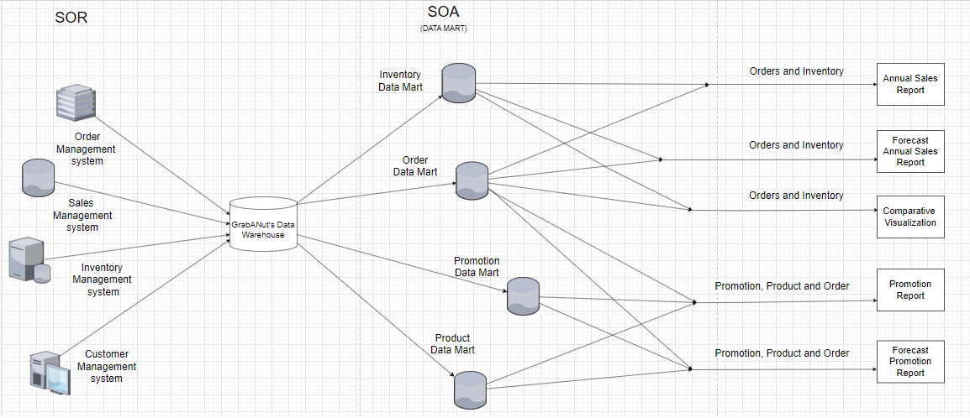

1. Data Collection: GrabANut collects all its data from System Of Records (SORs) which are: Order Management, Sales Management, and Customer Management System.
2. Data Warehousing: All the required data is structured and made consistent for ease of accessibility and further analysis.
3. Categorization of Data (Data Mart): Further the data is categorized into data marts. Here we have three different data marts: Product data mart, Inventory data mart, Promotion data mart, and Order data mart.

**BI and analytics solutions description**

**1. Annual Sales Report:**

An annual sales report overviews a company's sales performance over a given year. So, we will use inventory and orders for this implementation.

The Annual Report is extracted from **Orders and Inventory data marts**

**Orders:** Orders Data can be used to count the number of Items/commodities sold.

**Inventory:** Inventory data will help us to interpret the number of items left in our stock.

So, with the help of two data marts, we will be able to get:

* Order date and details for pistachios (product, quantity, price)
* Inventory levels at the beginning and end of each year.
* Returns or adjustments to pistachio inventory

**BI Style used**: Reporting

It helps us answer the following question.

**Question: What are the annual sales of all the categories of pistachios over the last 3 years?**

This data will be used by Business analysts.

**2. Comparative Visualization:**

The Comparative Visualization is done from **Orders and Inventory data marts**

**Orders:** Orders Data can be used to count the number of Items/commodities sold during which month.

**Inventory:** Inventory data will help us to interpret the number of items left in our stock.

So, with the help of two data marts, we will be able to get:

* Order date and details for pistachios (product, quantity, price)
* Inventory levels at the beginning and end of each year.
* We can compare the quarterly sales even using visualization tools such as bar graphs to analyze when the drop started.

**BI style used**: Visualization

This will answer the following question.

**Question: When was the drop in demand for the shelled pistachios observed?**

This data will be used by a Data Analyst.

**3. Promotion reports:** It helps us answer the above question.

A promotion report is a detailed report that shows the impact of each promotion on sales.

The Promotional Report is extracted from the **promotion, product, and order data mart.**

**Promotion:** Promotion Data mart can be used to find the promotions done for specific products and at which period.

**Products:** Products Data mart will help us understand how each category of pistachios was affected.

**Orders:** Order data mart will help us calculate the number of units sold against those promotions.

So, with the help of three data marts, we will be able to get:

* Product Details (e.g., Description, Price, Flavor variations)
* Order date and details for pistachios (product, quantity, price, units sold)
* Promotion dates and details

**BI Style used**: Visualization

This will answer the following Question-

**Question: How did previous marketing and promotional efforts affect the sales of pistachios?**

This data will be used by Market analysts.

**4. Forecast Promotion reports:** This helps us answer the above question.

A Forecast Promotion Report is a detailed report that shows how promotions can impact sales and what promotion impacts sales most.

The Forecast Promotion Report is extracted from the **promotion, product, and order data mart.**

**Promotion:** Promotion Data mart can be used to find the promotions done for specific products and at which period.

**Products:** Products Data mart will help us understand how each category of pistachios was affected.

**Orders:** Order data mart will help us calculate the no. of units sold against those promotions.

So, with the help of three data marts, we can prescribe what type of promotion strategy to use in the future and how we can improve.

So, with the help of three data marts, we will be able to get:

* Product Details (e.g., Description, Price, Flavor variations)
* Order date and details for pistachios (product, quantity, price, units sold)
* Promotion dates and details

This will Answer the following question

**Question:** How will marketing schemes affect the sales of pistachios in the future?

This data will be used by the Market Analyst

**5. Forecast Annual Sales Report:** It helps us answer the above question.

A forecast annual sales report predicts a company's sales performance for upcoming years. So, we will use inventory and orders for this implementation.

The Forecast Annual Sales Report is extracted from **Orders and Inventory data marts** by analyzing the trend in the previous years annual report.

**Orders:** Orders Data can be used to count the number of Items/commodities sold.

**Inventory:** Inventory data will help us to interpret the number of items left in our stock.

So, with the help of two data marts, we will be able to get:

* Order date and details for pistachios (product, quantity, price) sold in the previous years.
* Inventory levels at the beginning and end of each year of previous years

**BI Style used**: Predictive Analysis.

This will answer the following question

**Question:** What is the expected sales trend for shelled pistachios in the upcoming quarter, considering the historical decline in sales of shelled pistachios?

This data will be used by the Business Analyst

**Step 10 -**

**Scope Statement:**

The project aims to analyze GrabANut’s sales and marketing strategies related to pistachio products and the main focus is to identify patterns and trends that affect sales and therefore, suggest actions and recommendations.

**Main Business Stakeholders:**

* **Sales Department**:

**Interest:** Interested in understanding sales trends, identifying product performance issues, and optimizing marketing strategies to boost sales.

**Benefit**: They benefit from improved sales insights and targeted marketing efforts.

* **Inventory Management:**

**Interest:** Concerned with maintaining optimal stock levels, identifying slow-moving products, and managing inventory turnover.

**Benefit**: They benefit from accurate predictions of demand and improved inventory control.

* **Marketing Team:**

**Interest:** Focused on effective promotional strategies and understanding customer preferences.

**Benefit**: They benefit from insights into the impact of marketing efforts on sales.

* **Customer Support Teams:**

**Interest:** Interested in understanding customer behavior and preferences to enhance customer satisfaction.

**Benefit:** They benefit from improved customer relationship management.

**Project Phases:**

Project Plan for GrabANut Analytics Solution:

**1) Analysis and Definition:**

**Tasks:-**

* Defining the project scope, including objectives, deliverables, boundaries, and constraints.

**Roles Responsible:** Project Managers, in collaboration with Business Analysts and Subject Matter Experts (SMEs), determine what is in and out of scope.

* Conducting one-on-one or group discussions with stakeholders to gather insights and perspectives on project goals.

**Roles Responsible:** Project Managers, Business Analysts, or Team Leads who facilitate these interviews and discussions.

* Collecting and documenting business needs, functionalities, and expectations from stakeholders.

**Roles Responsible**: Business Analysts, Project Managers, or Functional Leads who engage with stakeholders to understand their requirements.

* Outlining the high-level plan for project execution, including timelines and resource estimations.

**Roles Responsible:** Project Managers develop an initial project plan based on the gathered information and requirements.

**2) Architect and Design:**

**Tasks:**-

* Developing a blueprint of the overall system architecture, including components, data flow, and integration points.

**Roles Responsible:** Solution Architects collaborate with System Designers and Data Engineers to create the architecture.

* Designing the structure, relationships, and schema of the database system.

**Roles Responsible:** Database Architects or Database Administrators design the database architecture and schema.

* Creating comprehensive documentation, including architectural diagrams, design documents, and technical guidelines.

**Roles Responsible:** Technical Architects, or designated team members prepare and maintain detailed documentation

**3) Build and Test:**

**Tasks:-**

* Performing the Data cleaning and Data Preparation activities. Understanding the structure, quality, and patterns, identifying inconsistencies, anomalies, or missing data points, and managing duplicate entries or records within the dataset. Transforming data types, formats, and structures as per requirement.

**Roles Responsible:** Data Analysts, Data Engineers, or SMEs examine the data to profile its characteristics, impute missing values, analyze outliers, and decide whether to remove, transform, or decide on strategies to handle them appropriately.

* Building software modules, analytical models, and functionalities and integrating different components to form a coherent system. Develop analytical models for descriptive, diagnostic, predictive, and prescriptive analysis.

**Roles Responsible:** Software Developers and Data Engineers develop the components based on design specifications.

* Conducting comprehensive tests on the integrated system to validate its overall functionality.

**Roles Responsible:** Quality Assurance (QA) Testers or Testing Teams perform various testing methodologies to ensure and validate proper system behavior and quality.

**4) Implementation:**

**Tasks:-**

* Installing the solution or application into the operational environment. Conducting tests to ensure the solution functions as intended. Optimizing the system's performance to ensure efficiency and scalability.

**Roles Responsible:** IT operations or deployment teams handle the installation process. Quality assurance (QA) teams or testers verify the solution's functionality and perform validation checks. Performance engineers or technical experts fine-tune the solution for optimal performance.

* Identifying and resolving bugs, issues, or discrepancies found during testing.

**Roles Responsible:** Developers, QA Engineers, or Bug Resolution Teams fix reported issues and ensure their resolution.

* Implement marketing and promotional strategies.

**Roles Responsible**: Marketing Analyst

**5) Deployment and Rollout:**

**Tasks:-**

* Deploy the analytics solution to relevant systems. Making the solution available for use across the organization.

**Roles Responsible:** Deployment teams or IT operations handle the deployment process and ensure a smooth rollout.

* Conducting a review after implementation to assess the solution's effectiveness

**Roles Responsible:** Project managers evaluate the implemented solution's success against predefined criteria

* Provide training and support to end-users to familiarize them with the new solution

**Roles Responsible:** Project Manager and Business Analysts conduct training and create user manuals or guides.

**OUR TEAM**

Project Manager - Taranjeet Kamboj

Subject Matter Expert - Vanshaj Sekhri

Business Analyst – Swathimathi G

Data Analyst – Ayantika Chatterjee

Data Engineer – Biswajit Dutta

QA Engineer – Alan K Mathew  
Market Analyst – Tashmeet Kaur Saluja

**Project Success Criteria:**

* Increase in sales for shelled pistachios.
* Improved overall revenue.
* Enhanced customer satisfaction.
* Efficient utilization of marketing budget.

Legal and ethical considerations are crucial in any analytics project, especially when handling sensitive data. Here are some concerns to keep in mind for GrabANut's analytics project:

**Data Privacy:**

**Retailer’s Information:** Protecting personally identifiable information of customers stored in systems like Customer Management is essential. Compliance with data privacy laws is critical.

**Food Industry Regulations:** Adhering to industry-specific regulations, such as those governing environmental standards, product safety, and food nutrition quality is essential. Compliance with regulations like ISO standards

**Ethical Considerations:**

* **Fair Use of Data:** Ensuring that data analysis doesn’t lead to discriminatory practices or biased decisions. Ethical AI and analytics approaches should be adopted to avoid biased outcomes in hiring, resource allocation, or product development.
* **Transparency and Consent:** Ensuring transparency with stakeholders about data collection and usage. This includes obtaining consent for data collection, especially from customers or suppliers.
* **Vendor and Partner Agreements:** Establish clear agreements with vendors and partners regarding data sharing, confidentiality, and intellectual property rights.

**Strategies to Deal with Concerns**:

Encryption and Access Controls: Implement robust encryption methods for sensitive data and enforce strict access controls to limit unauthorized access.

Regular Audits and Compliance Checks: Conduct regular audits to ensure compliance with industry standards and regulations, updating practices as needed.

By addressing these concerns proactively and integrating ethical and legal considerations into the analytics processes, manufacturing companies can mitigate risks, protect sensitive data, and uphold ethical standards while leveraging data-driven insights.

**Here are 7 key lessons that are commonly learned:**

1. **Communication**: Effective communication is paramount. Clear, frequent, and open communication channels among team members ensure everyone is on the same page, reducing misunderstandings and enhancing productivity.
2. **Roles and Responsibilities**: Defining roles and responsibilities within the team is crucial. It helps in task delegation, avoiding duplication of efforts, and ensuring accountability for each aspect of the project.
3. **Conflict Resolution:** Addressing conflicts constructively is vital. Conflicts can arise due to differing opinions or working styles. Learning to navigate and resolve conflicts amicably helps maintain team cohesion.
4. **Time Management**: Managing time effectively is essential. Meeting deadlines and milestones requires effective planning, setting priorities, and adhering to schedules to ensure project progress.
5. **Feedback and Reflection**: Embracing feedback loops and reflecting on team performance is valuable. Regularly reviewing progress, discussing successes and challenges, and incorporating feedback improves future collaboration.
6. **Flexibility and Adaptability:** Being adaptable to changes and flexible in approach is important. Projects evolve, and being open to adapting strategies or plans as needed enhances the team's agility. Utilizing Diverse Strengths: Recognizing and utilizing the strengths of each team member enhances overall project quality. Leveraging diverse skills and expertise within the team leads to comprehensive outcomes.
7. **Recognizing Unique Strengths:** Utilizing the strengths of each team member enhances overall project quality. Leveraging diverse skills and expertise within the team leads to comprehensive outcomes.

**The most difficult aspect often revolves around:**

**Collaboration Challenges:** Coordination across different schedules, time zones, or work styles can be challenging. Ensuring everyone contributes equally and aligns with the project's goals can sometimes pose difficulties.

In **real business projects**, similar challenges may arise:

**Communication and Coordination:** In a professional setting, communication barriers due to diverse teams, remote work, or varying time zones can hinder collaboration. Ensuring effective communication channels and tools becomes crucial.

**Conflict Resolution:** Conflicting priorities, opinions, or approaches can arise in business projects, requiring effective conflict resolution strategies to maintain team harmony and project progress.

Addressing these challenges in real business projects requires effective leadership, clear communication strategies, adaptable work approaches, and a focus on leveraging diversity as a strength rather than a challenge. The lessons learned from collaborative group assignments serve as a foundation for tackling similar challenges in professional environments.